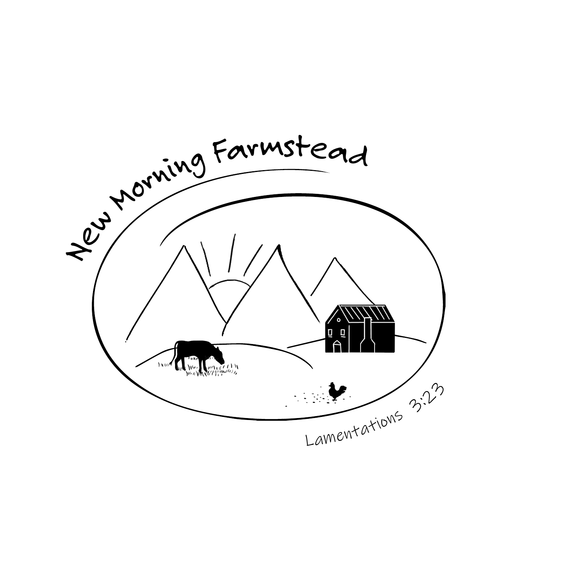
GOAT SALES TERMS
New Morning Farmstead, LLC
Effective July 8, 2026
BY PLACING A DEPOSIT, YOU CONFIRM THAT YOU HAVE READ, UNDERSTAND, AND AGREE TO THESE SALES TERMS.
1. Reservations & Deposits
A $50 non-refundable deposit reserves your place for a kid and may be applied toward your first or second-choice breeding. Reservations are first come, first served. A reservation is not secured until the completed deposit agreement and deposit have been received. Only two reservations will be accepted per doe, per breeding season.
2. Choosing a Breeding
Indicate your first-choice and second-choice breeding on the deposit agreement.
3. Herd Retention
New Morning Farmstead, LLC reserves the right to retain any kid born on the farm. If a requested breeding produces only one doe and the farm elects to retain her, your reservation will move to your next available choice. Planned herd-retained kids will be identified when determined.
4. Final Deposit
Once a matching kid is offered, a 50% deposit, less the initial $50 deposit when applicable, is due within 48 hours to secure that specific kid. No payment plans are accepted.
5. Payments & Non-Refundable Fees
Payments may be made by Check, Venmo, or PayPal. All payments—including deposits, veterinary fees, boarding, feed, or other expenses—are non-refundable if the buyer cancels for any reason.
6. If We Cannot Fulfill Your Reservation
If New Morning Farmstead, LLC cannot fulfill your reservation, your deposit may be transferred to another available kid that season, rolled over to the following year, or refunded.
7. Buck Kids
We typically do not sell intact buck kids from first fresheners, although they may be offered in some situations.
8. Pickup
Reserved animals must be picked up on the date identified by New Morning Farmstead, LLC. Failure to pick up on the agreed pickup date results in forfeiture of the reserved animal and any payments made. New Morning Farmstead, LLC may then offer the animal to another buyer.
New Morning Farmstead, LLC reserves the right to update these terms for future sales.

